National Coral Reef Monitoring Program

Climate Monitoring Brief: Dry Tortugas National Park

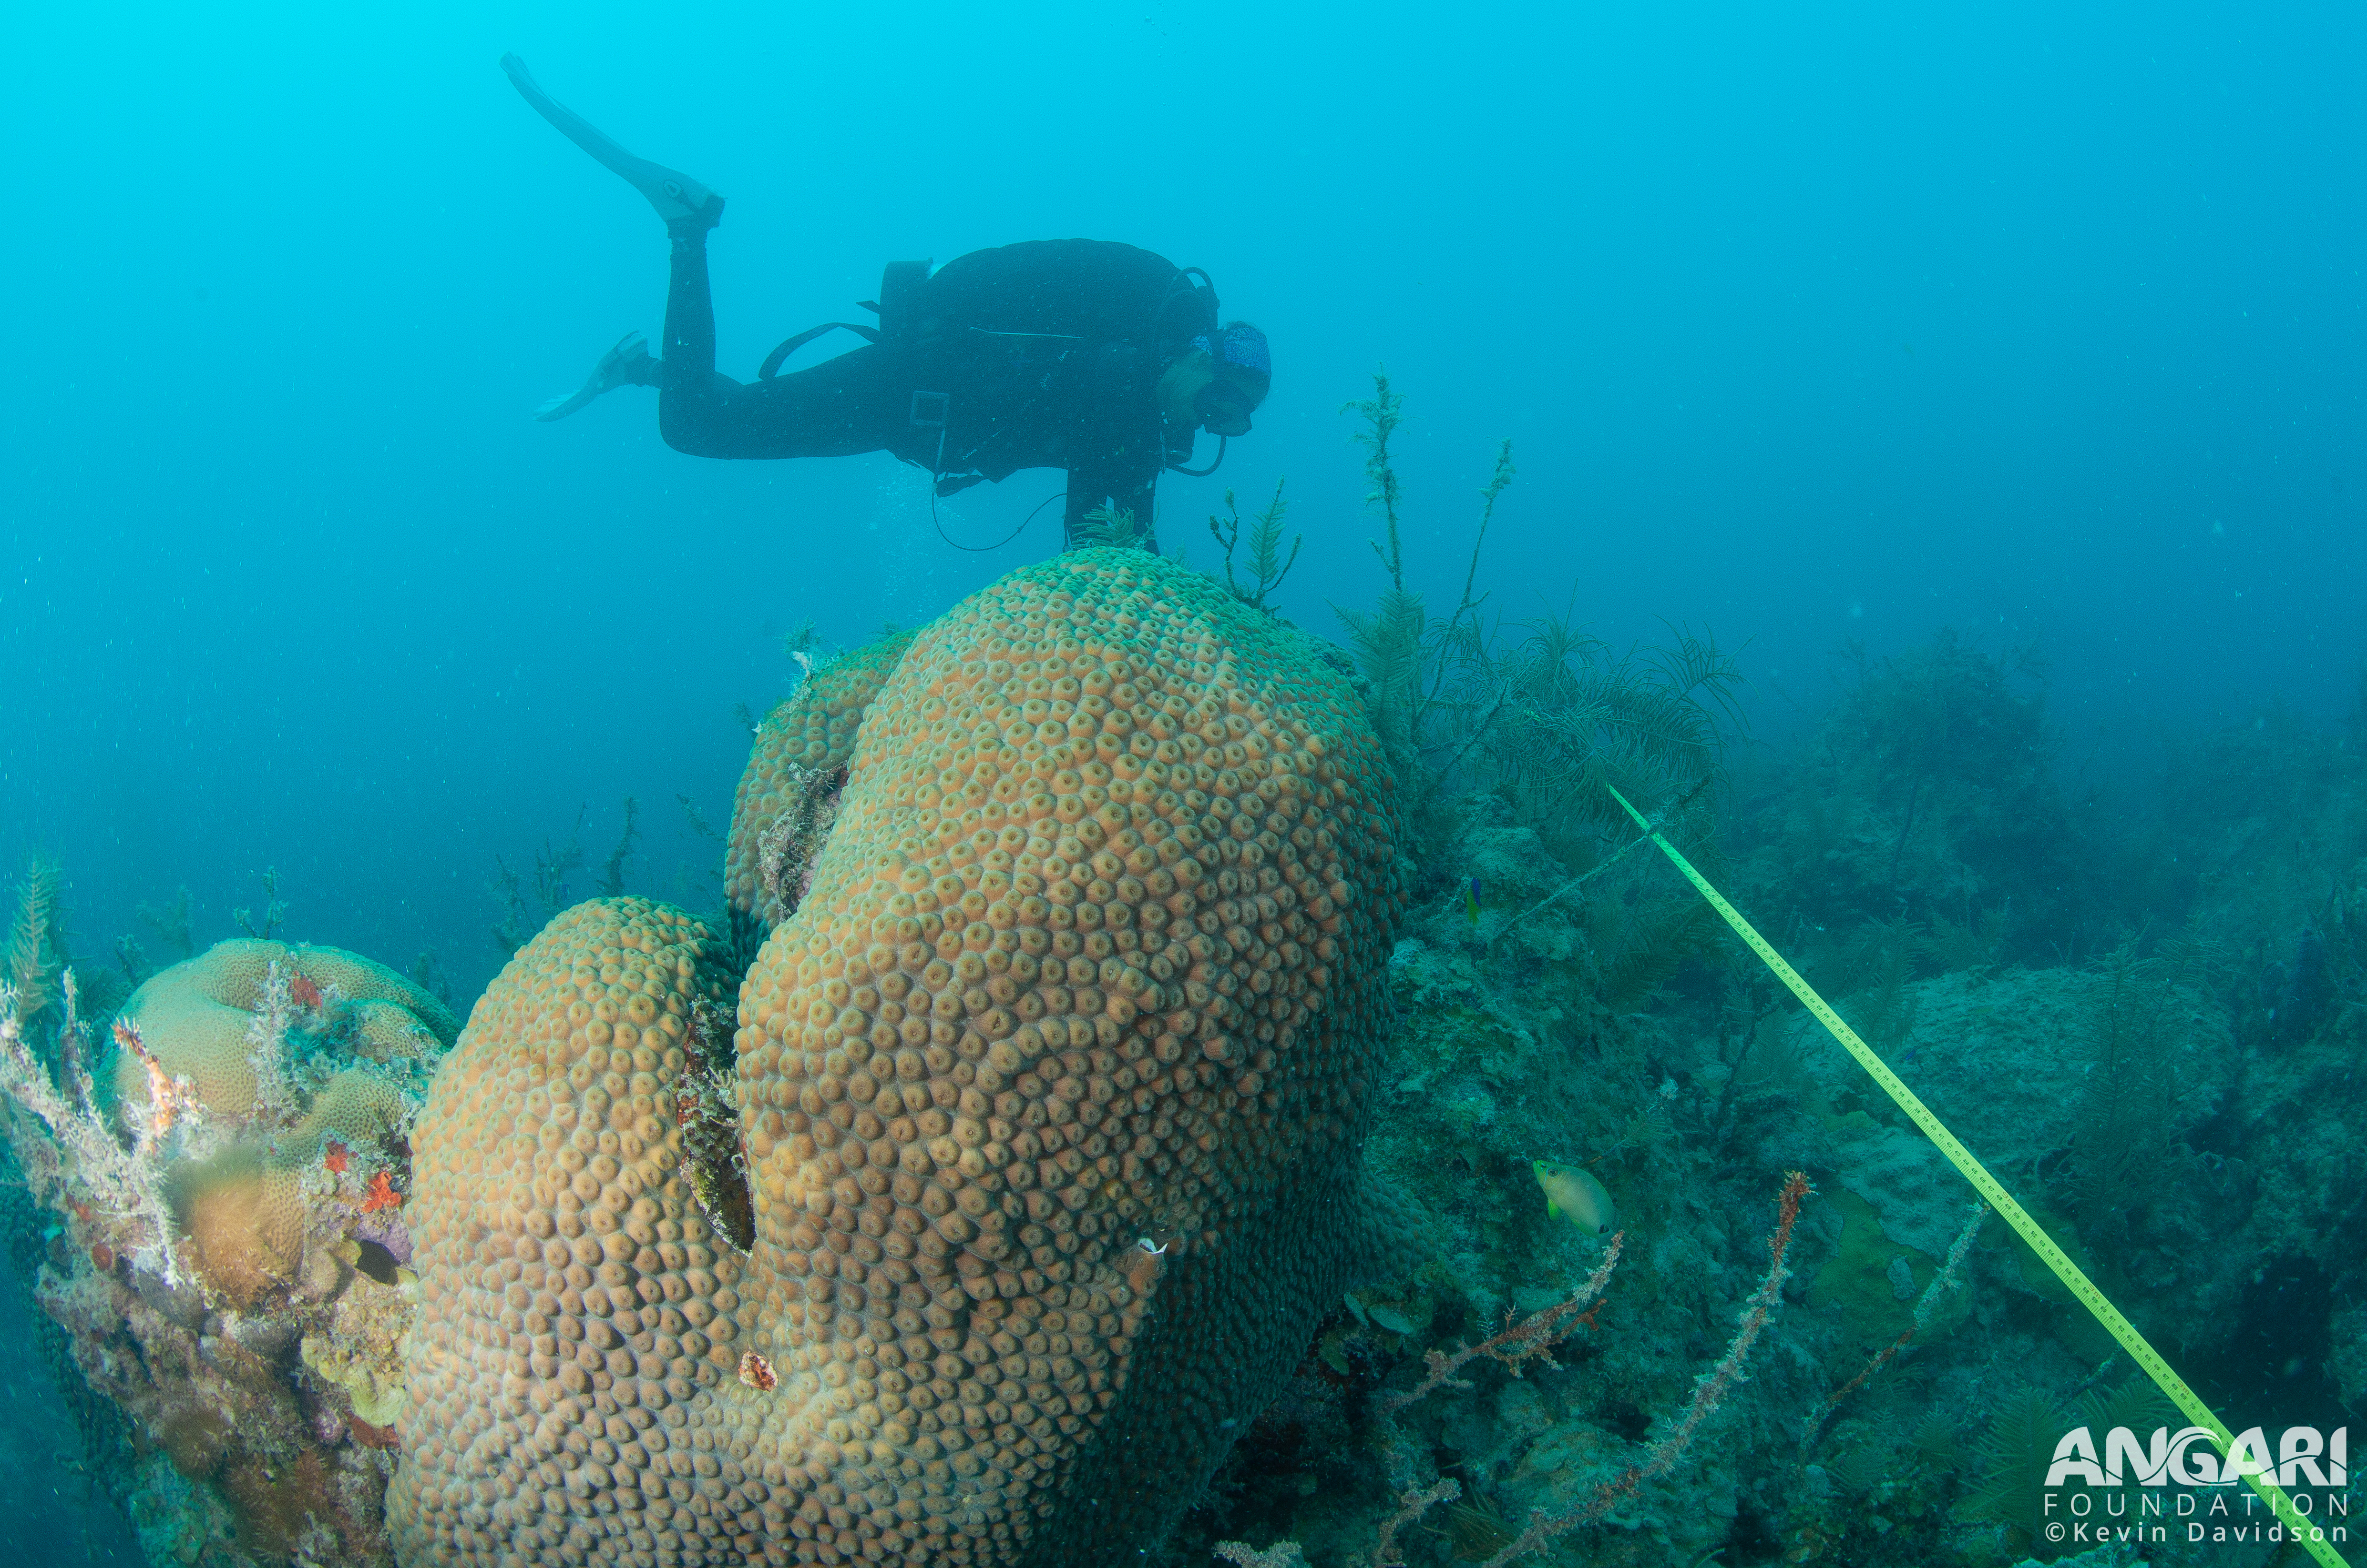

Diver collecting data in Dry Tortugas National Park

Atlantic Oceanographic & Meteorological Laboratory Coral Program University of Miami Cooperative Institute of Marine and Atmospheric Science National Oceanic Atmospheric Administration

N. Besemer, A. Palacio, M. Jankulak, A.Webb, I. Enochs - November 2024

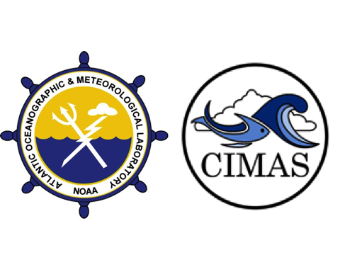

### Mission

The AOML Coral Program tracks the status and trends of coral reef ecosystems of the U.S. Atlantic and Caribbean as part of the National Coral Reef Monitoring Program (NCRMP). This summary brief provides an overview of the most recent climate monitoring efforts in Dry Tortugas National Park.

### Expedition summary

* The NCRMP Atlantic climate monitoring team surveyed Dry Tortugas National Park from June 23rd to June 27th 2024.
* Four different sites (Fig. 1) were visited by six team members and collaborators completing a total of 72 dives.

### Data collection summary

**Subsurface temperature:** Subsurface temperature recorders (STRs) were recovered and redeployed at four sites, representing four different depths (Fig. 1). In total, more than six hundred thousand temperature observations were collected from 4 instruments:

* **Pulaski Shoal (1m)**: 138,343 observations
* **White Shoal (5m)**: 151,014 observations
* **Bird Key Reef (15m)**: 227,726 observations
* **Black Coral Rock (25m)**: 156,816 observations

**NCRMP Climate fixed sentinel site monitoring:** At the Bird Key Reef, short term instruments (72h) were deployed to monitor daily fluctuations in:

* **Current**: 356 observations
* **pH**: 355 observations
* **Light**: 354 observations
* **Carbonate Chemistry**: 24 samples collected # NOT SURE ABOUT THIS NUMBER

**Habitat persistence:** Changes in bioerosion and calcification were monitored:

* **Carbonate budget surveys**: Benthic cover, sponge, urchin and parrotfish surveys completed at six transects
* **Bioerosion**: 10 Bioerosion Monitoring Units (BMUs) collected, 10 redeployed
* **Calcification**: 5 Calcification Accretions Units (CAUs) collected, 5 redeployed
* **Benthic cover**: 6 landscape mosaics

**Figure 1:** Study sites and depths in Dry Tortugas National Park area

#### Subsurface Temperature

The temperatures that marine organisms experience are a function of local oceanographic conditions and vary with depth. To monitor subsurface temperature, four sites were established around the national park. Each site represents four depths (1, 5, 15, 25m; Fig. 2). Temperature was measured using SeaBird Electronics Subsurface Temperature Recorders (STR)s that collected data at 5-minute intervals. Gaps exist in the data as not all instruments survived the extended deployment time (1m STR stopped recording on November 2022, 5m and 25m stopped recording on December 2022, and 15 m STR stopped recording August 2023)

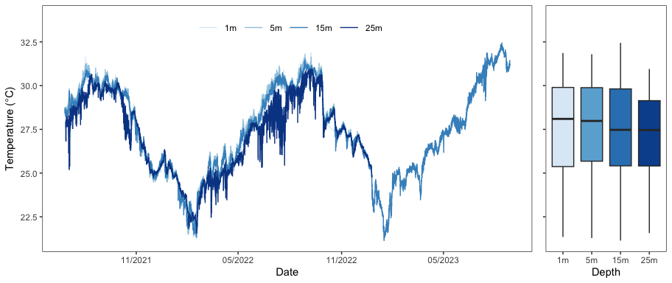

**Figure 2:** Temperature conditions at four sites in the Dry Tortugas representing a depth gradient: Pulaski Shoal Lighthouse (1m) White Shoal (5m), Bird Key Reef (15m), and Black Coral Rock (25m). Data were collected from June 2021 to October 2023 not lasting the full deployment period.

Mean temperature values were slightly higher at 1m, 5m, and 15m (27.6, 27.7, and 27.5 $​^{∘}$ C, respectively) compared to 25m (27.2 $​^{∘}$ C). The lowest monthly mean temperatures occurred in January or February (22.7, 23.0, and 23.5 and 22.9 $​^{∘}$ C, respectively) and the the higest monthly mean temperatures during August or September (30.3, 30.4, 30.7 and 30.0 $​^{∘}$ C, respectively; Fig. 2).

#### Diurnal Suite Deployment

Seawater carbonate chemistry can fluctuate diurnally due to biological forcing processes such as photosynthesis and respiration, as well as calcification and dissolution. To characterize this, discrete water samples (Fig. 3) were collected at three-hour intervals (n=15) using Subsurface Automatic Samplers (SAS, www.coral.noaa.gov/accrete/sas). These samples will be analyzed for Total Alkalinity (TA), Dissolved Inorganic Carbon (DIC), and Spectrophotometric pH (SpecpH), which will be used to calculate pCO2 and aragonite saturation state (ΩAragonite).

A suite of instruments was deployed for a 72-hour period at the Bird Key Reef 15m site. A SAMI pH was used to log pH, an EcoPAR measured Photosynthetically Active Radiation (PAR), and a Lowell Tiltmeter measured current speed and direction. Each instrument collected measurements at 15-minute intervals (Fig. 3).

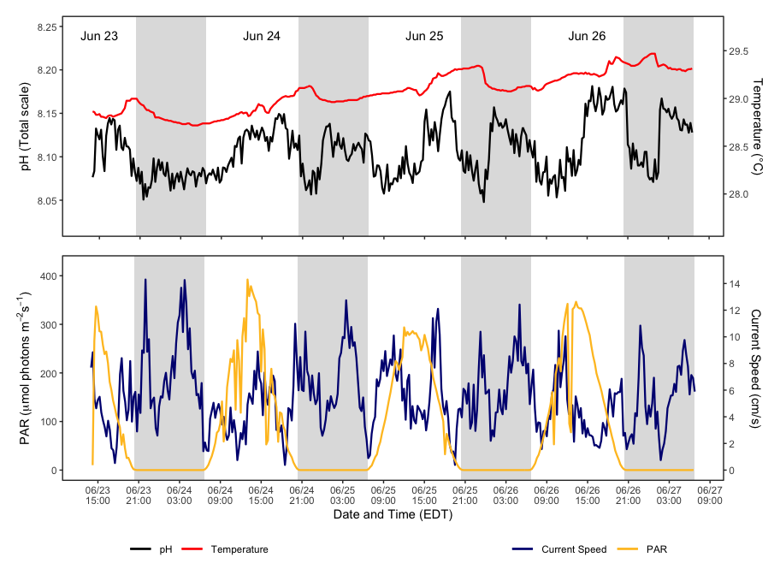

**Figure 3:** Bird Key Reef (15m) diurnal suite monitoring from June 23th to 27th. Top panel: pH and temperature from SeaFET. Bottom panel: Photosynthetically Available Radiation (PAR) and current speed from EcoPAR and Tiltmeter. Shading denotes nighttime throughout the sequence of the plot. Instruments measured parameters every 15 minutes

#### Habitat persistence

**Carbonate budget** assessments use transectbased surveys (ReefBudget, Perry et al. 2012) to quantify the abundance of carbonate producers (e.g., corals and crustose coralline algae, CCA), and carbonate bioeroders, (e.g., parrotfish and sea urchins). Abundances are multiplied by taxonspecific rates of carbonate alteration to determine if a reef is in a state of net accretion (habitat growth) or net loss (habitat loss; Fig. 4).

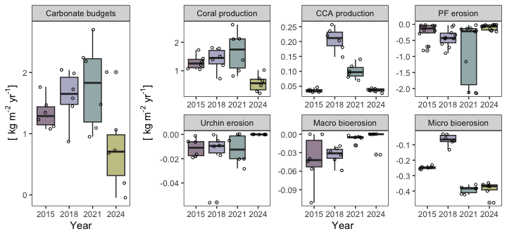

**Figure 4:** Net carbonate production and the magnitude of carbonate alteration by calcifying or bioeroding functional groups. CCA represents crustose coralline algae. PF represents parrotfish. The scale of the y-axis varies for each functional group.

At Bird Key Reef, six transects have been surveyed in 2015, 2018, 2021 and again in 2024 to obtain carbonate budgets (Fig. 4). These data show positive carbonate budgets all years, which implies that this site supported reef accretion. However, carbonate production significantly declined from 1.77 ± 0.72 (sd) kg m-2 yr-1 in 2021 to 0.77 ± 0.72 kg -2 -1 in 2024. This change was mainly driven by a reduction in coral production from 1.7 ± 0.72 in 2021 to 0.56 ± 0.30 in 2023.

**Landscape mosaics** are used to quantify the benthic community, and to monitor changes in coral cover over time. Thousands of underwater images are digitally stitched together to create a high-resolution archive of the reef at the time of collection.

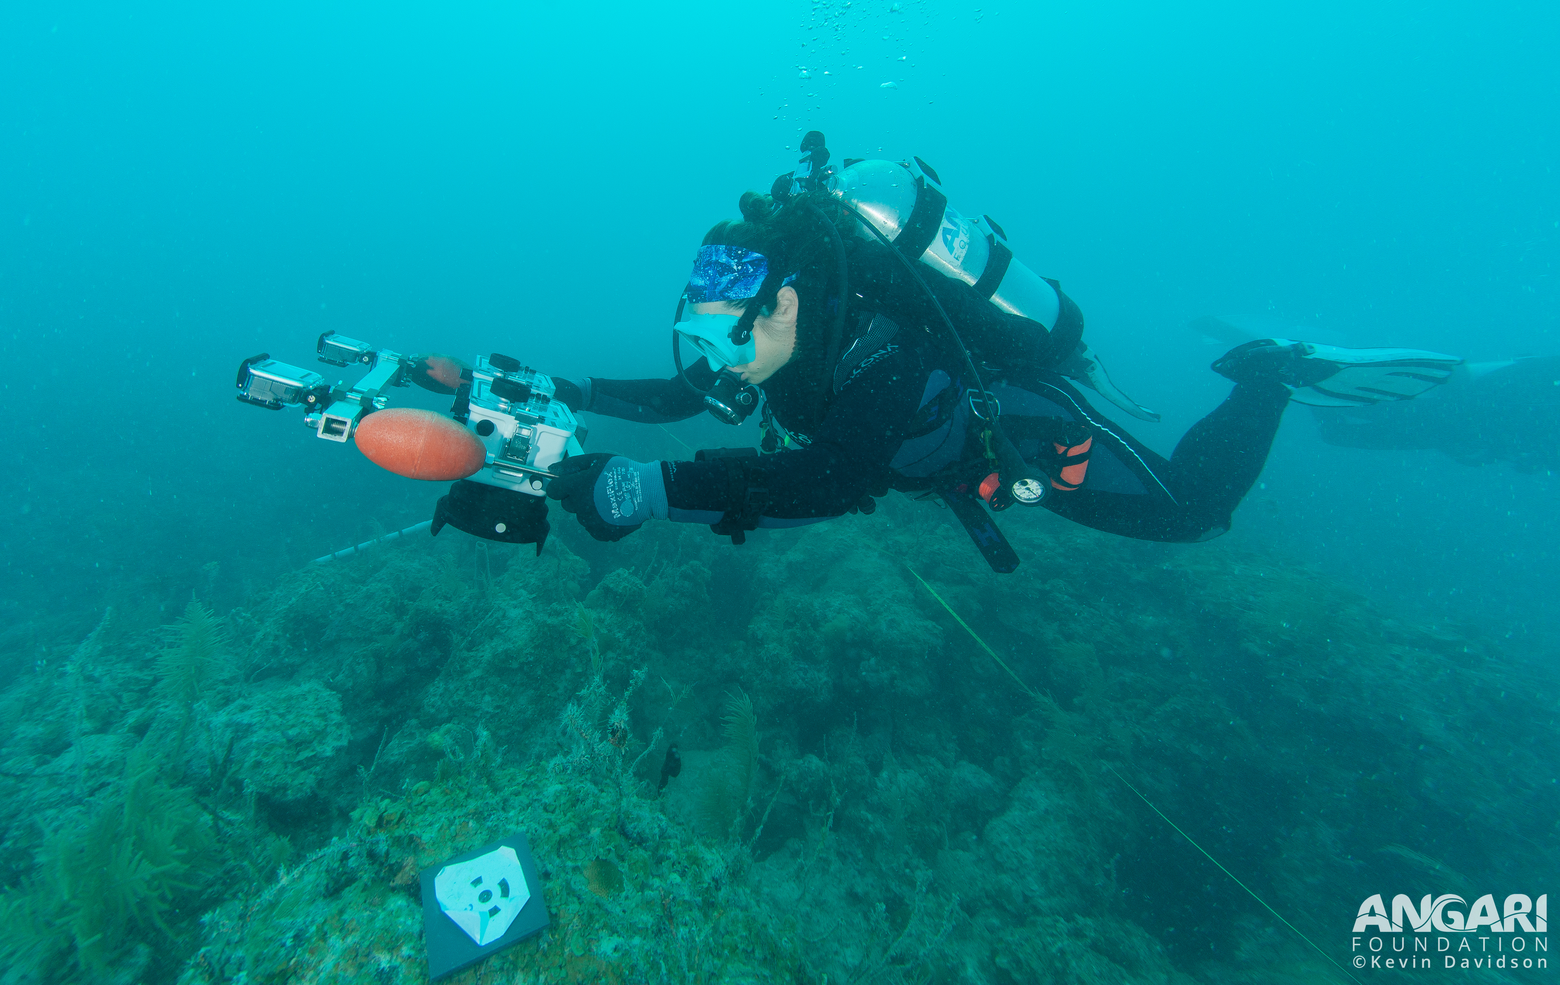

Figure 5: Diver collecting photos for landscape mosaics

**Calcification Accretion Units (CAUs)** and **Bioerosion Monitoring Units (BMUs)** were used to investigate the balance between calcification and erosion. CAUs and BMUs were collected and redeployed for the next sampling cycle. CAUs are processed by the NCRMP Pacific Climate group and the data will be available within a year. BMUs will be dried and cleaned using a hydrogen peroxide solution. Samples will be weighed and scanned using a CT scanner and then compared to their pre-scans to quantify bioerosion.

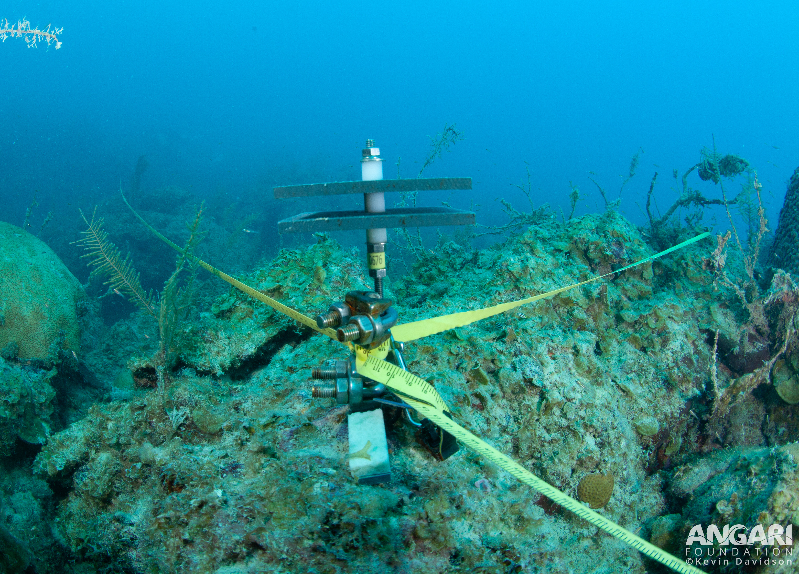

Figure 6:CAU and BMU pair deployed during the expedition. CAUs are two parallel PVC plates to quantify settled accretors. BMU is mounted coral skeleton installed at the base of the metal stake and has been encrusted.

### About the monitoring program

AOML’s climate monitoring is a key part of the National Coral Reef Monitoring Program of NOAA’s Coral Reef Conservation Program (CRCP), providing integrated, consistent, and comparable data across U.S. Managed coral reef ecosystems. CRCP monitoring efforts aim to:

* Document the status of reef species of ecological and economic importance
* Track and assess changes in reef communities in response to environmental stressors or human activities
* Deliver high–quality data, data products, and tools to the coral reef conservation community

### Point of Contact

Atlantic Climate team lead: [nicole.besemer@noaa.gov](mailto:nicole.besemer@noaa.gov)

Principal Investigator: [ian.enochs@noaa.gov](mailto:ian.enochs@noaa.gov)

NCRMP Coordinator: [erica.towle@noaa.gov](mailto:erica.towle@noaa.gov)

### For more information

Coral Reef Conservation Program: <http://coralreef.noaa.gov>

NCRMP climate monitoring: <https://www.coris.noaa.gov/monitoring/climate.html>

NOAA Atlantic Oceanographic and Meteorological Laboratory: <http://www.aoml.noaa.gov/>

[Florida Coral Reef Status Report 2020](https://www.coris.noaa.gov/monitoring/status_report/docs/FL_508_compliant.pdf)

[National Coral Reef Status Report 2020](https://repository.library.noaa.gov/view/noaa/27295)

### Acknowledgements

These efforts were jointly funded by NOAA’s CRCP project #743 and OAP. We would like to thank the National Park Service and Florida Keys National Marine Sanctuary for permitting support and the ANGARI Foundation for field support.

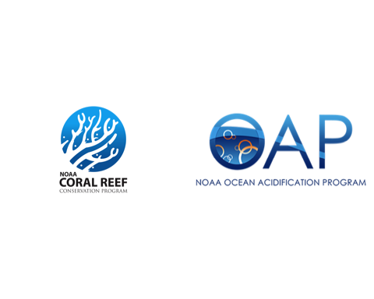

### Our Team

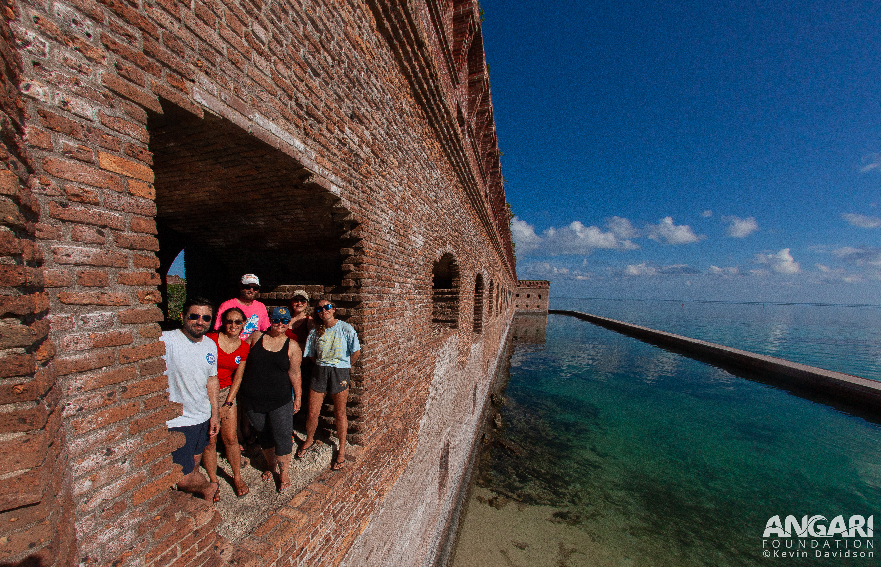

**Field team members**: Nicole Besemer, Ana Palacio, Ian Enochs, Taylor Gill, Rich Karp, and Ashley Stevens

**Additional lab members involved with NCRMP**: Benjamin Chomitz, Albert Boyd, Mike Jankulak, Alice Webb